Press Release

Faster, more Precise and more Flexible Grinding

3M at GrindingHub 2024: New Abrasives for Complex Processes

3M is presenting new high-performance abrasives for a wide range of applications at the GrindingHub in Stuttgart from May 14th to 17th, 2024. Trade fair visitors will find the 3M stand in Hall H09, Stand B21. The GrindingHub is an international trade fair for grinding industry professionals and offers an ideal platform for networking, knowledge exchange and the presentation of state-of-the-art technologies.

At GrindingHub 2024, 3M will present visitors with new developments in abrasive solutions. From precision grinding to finishing, 3M offers a comprehensive range of products to increase efficiency, quality and performance in a wide range of applications.

New Products
In addition, 3M is showcasing their new 6JGS/6JGM diamond dressing rolls for gear grinding at the fair. Also on display will be the ceramic diamond grinding wheel 6CVZ D93 for particularly efficient grinding of indexable inserts. A special highlight at the trade fair will be the additive manufactured ceramic CBN grinding tools 1PVP, which demonstrate the special advantages of 3D printing such as homogeneity and freedom of design. The newly tuned 3M Cubitron™ II ceramic grinding wheel 92VC also impresses with its homogeneous structure for improved performance in surface and profile grinding. All new 3M abrasives can be individually adapted to customer needs in terms of both geometry and specification (grain size, type of grain, concentration).

Innovative Solutions
“GrindingHub offers us a valuable opportunity to connect with grinding specialists, share insights and showcase new solutions that 3M is known for,” says Wilbert van den Berg, Precision Grinding & Finishing Global Business Leader at 3M. “We look forward to introducing our technologies and collaborating with prospects and customers to address their specific needs and challenges.”

Optimal Grinding processes
3M's participation in GrindingHub underlines the multi-technology group's commitment to continually developing advanced solutions for the abrasive industry. Visitors to the trade fair are cordially invited to visit the 3M stand B21 in Hall H09. There you can get to know the latest products and find out how 3M helps you successfully optimize grinding processes.

Further information at www.3M.com/precisiongrinding

Neuss, April 2, 2024

Characters with spaces: 2.322

About 3M
At 3M, we apply science in collaborative ways to improve lives daily. With $32 billion in sales, our 95,000 employees connect with customers all around the world. Learn more about 3M’s creative solutions to the world’s problems at www.3M.com.

3M and Cubitron II are trademarks of 3M Company.

Caption:
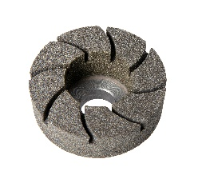
Filename: 3M ceramic CBN grinding tools 1PVP Product image: The 3M ceramic CBN grinding tools 1PVP show the special advantages of 3D printing. Photo: 3M.

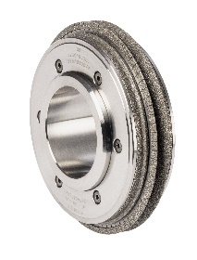
3M diamond dressing rolls 6JGS Product image: The 3M diamond dressing rolls 6JGS are a new solution for gear grinding. Photo: 3M.

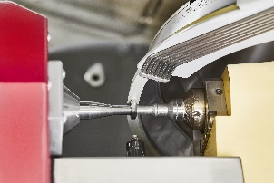
3M ceramic diamond grinding wheel 6CVZ D93 Application image: The new ceramic diamond grinding wheel 6CVZ D93 is particularly suitable for efficient grinding of indexable inserts. Photo: 3M

Press contact 3M: Dennis Breuer, Phone.: +49 241 88970-600
E-Mail: breuer@tema.de

Customer contact 3M: Friedrich Saemann, Phone.: +49 2131 14-3201
E-Mail: fsaemann@mmm.com

